
NORTHERN EDUCATION DIVISION
2025 MSCE MOCK EXAMINATION
ADDITIONAL MATHEMATICS
PAPER II
Thursday, 1 April. (100 marks) Subject Number: M132/II.
Time Allowed: 2hours 30 min.
10:30-1:00 pm.
Question number | Tick if answered | Do not write in these columns
1
2
3
4
5
6
7
8
9
10
 | Total
Instructions:
- This paper contains 12 pages. Please check.
- Answer all 7 questions in section A and any two questions in section B.
- Section A carries 60 marks and section B carries 40 marks
- The maximum number of marks for each answer is indicated against each question.
- Write your answers in the spaces provided on the question paper
- Calculators may be used.
- All working must be clearly shown.
- Write your name at the top of each page on your question paper in the spaces provided.
- In the table provided on this page, tick against the question number you have answered.

Section A (60 marks)
Answer all the seven questions from this section.
- Evaluate $\sum_{p=4}^{12}{\left(2p+2\right).}$ (4 marks)

- The position vectors of A and B from the origin are $\underline{i}$ - 2 $\underline{j}$ + $Q\underline{k}$ and 5$\underline{i}$ + $\underline{2j}$ - 5$\underline{k}$ respectively. Given that $\left|\vec{AB}\right|=2\sqrt{10}$, calculate
the values of Q. (6 marks)

- a. A body of mass 10 kg has an initial velocity of ( $\underline{i}$ + 4$\underline{j}$ ) m/s. When a constant force has acted on the body for 5 seconds the velocity is (5$\underline{i}$ + 2$\underline{j}$) m/s. Calculate the value of the force. (5 marks)

b. A football player is expected to take 12 penalties during training session. Calculate the probability of a player scoring at least 70% of the penalties. (6 marks)

- Given that matrix P = $\left[\begin{matrix}-2 & 0 \\ 1 & 4\end{matrix}\right]$ and Q = $\left[\begin{matrix}7 & 1 \\ 1 & -2\end{matrix}\right]$. Find the P⁻¹Q^{T}. (6 marks)

- Express the following series in sigma notation: 3, 5 , 7, + + + + + + 55. (5 marks)

- a. A golf ball is thrown from the top of a building in the air with a speed of 15 m/s at an angle of 30⁰. Calculate the time of flight of the ball. (8 marks)

b. Using inverse of matrices solve the simultaneous equations: (8 marks)
$x-3y=9$
$2x+y=-10$

- a. A data set is given by $\left\{1,2, 3,4,5, 6,7,8,9,\right\}.$ Calculate the probability of selecting a number at random that is a factor of 12 given that it is even. (5 marks)

- Find the equation of a circle passing through points A = (1,6), B = (0,5) and C = (7, -2) in the form of $x^{2}+y^{2}+2fx+2gy+c=0$. (7 marks)

Section B (40 Marks)
Answer any two questions from this section.
- The table below shows masses of 30 people which were obtained from Sopelera township.

M | 21 - 30 | 31 - 40 | 41 - 50 | 51 - 60 | 61 - 70 | 71 - 80 | 81 - 90
F | 0 | 1 | 1 | 3 | 6 | 9 | 7

- Calculate the mean mass. (5 marks)

- (i) Construct a cumulative frequency table. (5 marks)

(ii) Draw a cumulative frequency curve. (5 marks)

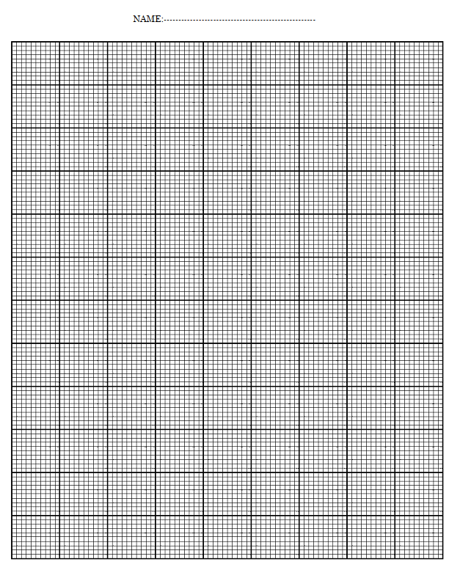

(iii) Estimate the semi-interquartile . (5 marks)

- a. Four forces simultaneously act on a stationary particle as follows: 2N due West, 1N in the direction of N61⁰W, 7N in the direction N46⁰E and 1N due South. Calculate the magnitude and direction of the resultant force. (10 marks)

- Given the equation of a circle $x^{2}+ y^{2}-2y-2x=7$ and that of a line $3x + 4y = 7$. Show that the line is a tangent to the circle.
- marks)

10. a. Show that the power series converges $\frac{6}{p^{2}+5p+6}$ converges and find its partial sum. (10 marks)

b The table below shows the frequency distribution of number of cars in households in a street.

Number of cars | Frequency
1 | $$a$$
2 | $$b$$

Show that the variance is given by $\frac{ab}{{\left(a+b\right)}^{2}.}$ (10 marks)

END OF QUESTION PAPER
NOTE: This paper contains 12 printed pages.

